BASIC INFORMATION
Name: |  |  |  |  |  |  | 9th Grade Entry Date:
High School Attending: |  |  |  |  |  |  | Originating Middle School:
EDUCATION GOALS
Exit Document |  | Jump Start Diploma Certificate of Achievement
Diploma Endorsements |  | Academic Endorsement |  |  |  |  | Career/Technical Endorsement
 |  | Community Service Endorsement |  |  |  |  | Other:
Post-Secondary Education Plans |  | Technical College Community College |  |  |  |  | Other:
CAREER GOALS (*Information here should be aligned to the Employment goal on the IEP.)
Career Specialty/Occupation (Option 1): |  |  |  |  |  | Career Specialty/Occupation (Option 2):
Post-High School Work Force Plans: |  |  |  | On-the-Job Training Employment Supported Employment Other:
COURSE SELECTIONS FOR YOUR CHOSEN PATHWAY
Subjects | Transitional 9th Grade (if applicable) |  | 9th Grade |  | 10th Grade |  |  | 11th Grade | 12th Grade |  | Graduation Tracker
 |  |  |  |  |  |  |  |  |  |  | Min Req | Earned | Enrolled | Must Complete
English |  |  |  |  |  |  |  |  |  |  | 4
Mathematics |  |  |  |  |  |  |  |  |  |  | 4
Science |  |  |  |  |  |  |  |  |  |  | 2
Social Science |  |  |  |  |  |  |  |  |  |  | 2
Workforce and Career Electives |  |  |  |  |  |  |  |  |  |  | 7-9
General Electives  (may include  Health and PE) |  |  |  |  |  |  |  |  |  |  | 2-4
Credit Totals |  |  |  |  |  |  |  |  |  |  | 23
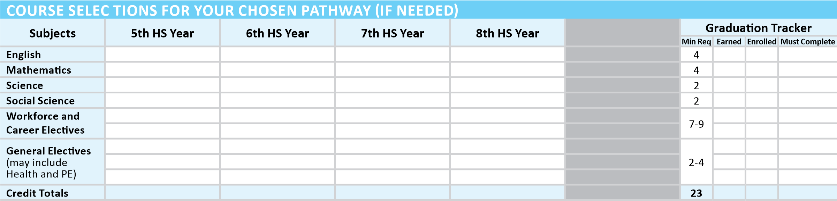
EXTRACURRICULAR & EMPLO |  | YMENT ACTIVITIES
Extracurricular |  |  |  |  |  |  |  |  |  |  |  |  | Awards/Industry-Based Certifications
Employment
Community Service
SIGNATURE APPROVAL
 | 8th/T9 |  | Date | 9th |  | Date | 10th |  | Date | 11th |  | Date | 12th | Date
Student
Parent
Special Education Teacher
Counselor/Advisor
May 1, 2015

